Creacion de AXI Stream

Implementación del ZYNQ:

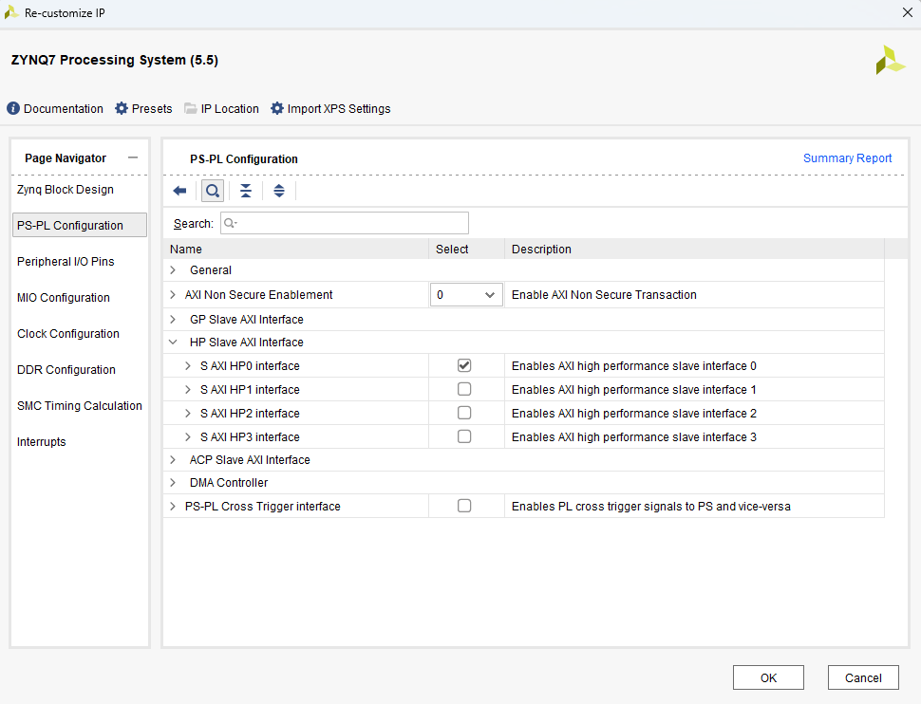

Clock Wizard

XADC

Xconstant para el address

AXI DMA:

library ieee;

use ieee.std_logic_1164.all;

use ieee.numeric_std.all;

entity ADC_Stream_v1_0_M00_AXIS is

generic (

-- Users to add parameters here

-- User parameters ends

-- Do not modify the parameters beyond this line

-- Width of S_AXIS address bus. The slave accepts the read and write addresses of width C_M_AXIS_TDATA_WIDTH.

C_M_AXIS_TDATA_WIDTH : integer := 32;

-- Start count is the number of clock cycles the master will wait before initiating/issuing any transaction.

C_M_START_COUNT : integer := 32

);

port (

-- Users to add ports here

-- %%%%%%%%%%%%%%%%%%%%%%%%%%%%%%%%%%%%%%%%%%%%%%%%%%%%%%%%%%%%%%%%

-- Codigo agregado por Fabian

-- Se agregan los puertos para el IP

data_in : in std_logic_vector(15 downto 0);

clk_adc : in std_logic;

-- %%%%%%%%%%%%%%%%%%%%%%%%%%%%%%%%%%%%%%%%%%%%%%%%%%%%%%%%%%%%%%%%

-- User ports ends

-- Do not modify the ports beyond this line

-- Global ports

M_AXIS_ACLK : in std_logic;

--

M_AXIS_ARESETN : in std_logic;

-- Master Stream Ports. TVALID indicates that the master is driving a valid transfer, A transfer takes place when both TVALID and TREADY are asserted.

M_AXIS_TVALID : out std_logic;

-- TDATA is the primary payload that is used to provide the data that is passing across the interface from the master.

M_AXIS_TDATA : out std_logic_vector(C_M_AXIS_TDATA_WIDTH-1 downto 0);

-- TSTRB is the byte qualifier that indicates whether the content of the associated byte of TDATA is processed as a data byte or a position byte.

M_AXIS_TSTRB : out std_logic_vector((C_M_AXIS_TDATA_WIDTH/8)-1 downto 0);

-- TLAST indicates the boundary of a packet.

M_AXIS_TLAST : out std_logic;

-- TREADY indicates that the slave can accept a transfer in the current cycle.

M_AXIS_TREADY : in std_logic

);

end ADC_Stream_v1_0_M00_AXIS;

architecture implementation of ADC_Stream_v1_0_M00_AXIS is

-- Total number of output data

--%%%%%%%%%%%%%%%%%%%%%%%%%%%%%%%%%%%%%%%%%%%%%%%%%%%%%%%%%%%%%%%%%

-- Codigo agregado por Fabian

-- Este valor se edita para variar el tamaño del buffer de salida

constant NUMBER_OF_OUTPUT_WORDS : integer := 8191; --13 bits --8;

--%%%%%%%%%%%%%%%%%%%%%%%%%%%%%%%%%%%%%%%%%%%%%%%%%%%%%%%%%%%%%%%%%

-- function called clogb2 that returns an integer which has the

-- value of the ceiling of the log base 2.

function clogb2 (bit_depth : integer) return integer is

variable depth : integer := bit_depth;

variable count : integer := 1;

begin

for clogb2 in 1 to bit_depth loop -- Works for up to 32 bit integers

if (bit_depth <= 2) then

count := 1;

else

if(depth <= 1) then

count := count;

else

depth := depth / 2;

count := count + 1;

end if;

end if;

end loop;

return(count);

end;

-- WAIT_COUNT_BITS is the width of the wait counter.

constant WAIT_COUNT_BITS : integer := clogb2(C_M_START_COUNT-1);

-- In this example, Depth of FIFO is determined by the greater of

-- the number of input words and output words.

constant depth : integer := NUMBER_OF_OUTPUT_WORDS;

-- bit_num gives the minimum number of bits needed to address 'depth' size of FIFO

constant bit_num : integer := clogb2(depth);

-- Define the states of state machine

-- The control state machine oversees the writing of input streaming data to the FIFO,

-- and outputs the streaming data from the FIFO

type state is ( IDLE, -- This is the initial/idle state

INIT_COUNTER, -- This state initializes the counter, once

-- the counter reaches C_M_START_COUNT count,

-- the state machine changes state to SEND_STREAM

SEND_STREAM); -- In this state the

-- stream data is output through M_AXIS_TDATA

-- State variable

signal mst_exec_state : state;

-- Example design FIFO read pointer

signal read_pointer : integer range 0 to depth-1;

-- AXI Stream internal signals

--wait counter. The master waits for the user defined number of clock cycles before initiating a transfer.

signal count : std_logic_vector(WAIT_COUNT_BITS-1 downto 0);

--streaming data valid

signal axis_tvalid : std_logic;

--streaming data valid delayed by one clock cycle

signal axis_tvalid_delay : std_logic;

--Last of the streaming data

signal axis_tlast : std_logic;

--Last of the streaming data delayed by one clock cycle

signal axis_tlast_delay : std_logic;

--FIFO implementation signals

signal stream_data_out : std_logic_vector(C_M_AXIS_TDATA_WIDTH-1 downto 0);

signal tx_en : std_logic;

--The master has issued all the streaming data stored in FIFO

signal tx_done : std_logic;

--%%%%%%%%%%%%%%%%%%%%%%%%%%%%%%%%%%%%%%%%%%%%%%%%%%%%%%%%%%%%%%%%%

-- Codigo agregado por Fabian

-- Senales agregadas para funciones del fifo

type datos_fifo is array (0 to NUMBER_OF_OUTPUT_WORDS + 5 ) of std_logic_vector(15 downto 0);

signal dfifo : datos_fifo := (others => (others => '0'));

signal act : std_logic;

signal contadorfifo : integer := 0;

signal activar : std_logic := '0';

--%%%%%%%%%%%%%%%%%%%%%%%%%%%%%%%%%%%%%%%%%%%%%%%%%%%%%%%%%%%%%%%%%

begin

-- I/O Connections assignments

M_AXIS_TVALID <= axis_tvalid_delay;

M_AXIS_TDATA <= stream_data_out;

M_AXIS_TLAST <= axis_tlast_delay;

M_AXIS_TSTRB <= (others => '1');

-- Control state machine implementation

process(M_AXIS_ACLK)

begin

if (rising_edge (M_AXIS_ACLK)) then

if(M_AXIS_ARESETN = '0') then

-- Synchronous reset (active low)

mst_exec_state <= IDLE;

count <= (others => '0');

else

case (mst_exec_state) is

when IDLE =>

-- The slave starts accepting tdata when

-- there tvalid is asserted to mark the

-- presence of valid streaming data

--if (count = "0")then

mst_exec_state <= INIT_COUNTER;

--else

-- mst_exec_state <= IDLE;

--end if;

--%%%%%%%%%%%%%%%%%%%%%%%%%%%%%%%%%%%%%%%%%%%%%%%%%%%%%%%%%%%%%%%%%

-- Codigo agregado por Fabian

-- Inicializacion de contadores

contadorfifo <= 0;

read_pointer <= 0;

activar <= '0';

--%%%%%%%%%%%%%%%%%%%%%%%%%%%%%%%%%%%%%%%%%%%%%%%%%%%%%%%%%%%%%%%%%

when INIT_COUNTER =>

-- This state is responsible to wait for user defined C_M_START_COUNT

-- number of clock cycles.

-- if ( count = std_logic_vector(to_unsigned((C_M_START_COUNT - 1), WAIT_COUNT_BITS))) then

-- mst_exec_state <= SEND_STREAM;

-- else

-- count <= std_logic_vector (unsigned(count) + 1);

-- mst_exec_state <= INIT_COUNTER;

-- end if;

--%%%%%%%%%%%%%%%%%%%%%%%%%%%%%%%%%%%%%%%%%%%%%%%%%%%%%%%%%%%%%%%%%

-- Codigo agregado por Fabian

-- Pasa directo al llenado del Stream

mst_exec_state <= SEND_STREAM;

act <= '0';

--%%%%%%%%%%%%%%%%%%%%%%%%%%%%%%%%%%%%%%%%%%%%%%%%%%%%%%%%%%%%%%%%%

when SEND_STREAM =>

-- The example design streaming master functionality starts

-- when the master drives output tdata from the FIFO and the slave

-- has finished storing the S_AXIS_TDATA

--%%%%%%%%%%%%%%%%%%%%%%%%%%%%%%%%%%%%%%%%%%%%%%%%%%%%%%%%%%%%%%%%%

-- Codigo agregado por Fabian

-- LLenado del buffer intermedio

if activar = '0' and clk_adc = '1' then

activar <= '1';

if contadorfifo < NUMBER_OF_OUTPUT_WORDS+5 then

dfifo(contadorfifo) <= data_in;

contadorfifo <= contadorfifo + 1;

end if;

elsif clk_adc = '0' then

activar <= '0';

end if;

--%%%%%%%%%%%%%%%%%%%%%%%%%%%%%%%%%%%%%%%%%%%%%%%%%%%%%%%%%%%%%%%%%

--%%%%%%%%%%%%%%%%%%%%%%%%%%%%%%%%%%%%%%%%%%%%%%%%%%%%%%%%%%%%%%%%%

-- Codigo agregado por Fabian

-- Envio de datos por el AXI Stream

axis_tvalid <= '1';

if read_pointer <= NUMBER_OF_OUTPUT_WORDS and M_AXIS_TREADY = '1' then

read_pointer <= read_pointer + 1;

stream_data_out <= "0000000000000000" & dfifo(read_pointer);

act <= '1';

elsif read_pointer > NUMBER_OF_OUTPUT_WORDS then

mst_exec_state <= IDLE;

elsif M_AXIS_TREADY = '0' and act = '1' then

mst_exec_state <= IDLE;

end if;

--%%%%%%%%%%%%%%%%%%%%%%%%%%%%%%%%%%%%%%%%%%%%%%%%%%%%%%%%%%%%%%%%%

-- if (tx_done = '1') then

-- mst_exec_state <= IDLE;

-- else

-- mst_exec_state <= SEND_STREAM;

-- end if;

when others =>

mst_exec_state <= IDLE;

end case;

end if;

end if;

end process;

--tvalid generation

--axis_tvalid is asserted when the control state machine's state is SEND_STREAM and

--number of output streaming data is less than the NUMBER_OF_OUTPUT_WORDS.

-- axis_tvalid <= '1' when ((mst_exec_state = SEND_STREAM) and (read_pointer < NUMBER_OF_OUTPUT_WORDS)) else '0';

-- AXI tlast generation

-- axis_tlast is asserted number of output streaming data is NUMBER_OF_OUTPUT_WORDS-1

-- (0 to NUMBER_OF_OUTPUT_WORDS-1)

axis_tlast <= '1' when (read_pointer = NUMBER_OF_OUTPUT_WORDS-1) else '0';

-- Delay the axis_tvalid and axis_tlast signal by one clock cycle

-- to match the latency of M_AXIS_TDATA

process(M_AXIS_ACLK)

begin

if (rising_edge (M_AXIS_ACLK)) then

if(M_AXIS_ARESETN = '0') then

axis_tvalid_delay <= '0';

axis_tlast_delay <= '0';

else

axis_tvalid_delay <= axis_tvalid;

axis_tlast_delay <= axis_tlast;

end if;

end if;

end process;

--read_pointer pointer

-- process(M_AXIS_ACLK)

-- begin

-- if (rising_edge (M_AXIS_ACLK)) then

-- if(M_AXIS_ARESETN = '0') then

-- read_pointer <= 0;

-- tx_done <= '0';

-- else

-- if (read_pointer <= NUMBER_OF_OUTPUT_WORDS-1) then

-- if (tx_en = '1') then

-- -- read pointer is incremented after every read from the FIFO

-- -- when FIFO read signal is enabled.

-- read_pointer <= read_pointer + 1;

-- tx_done <= '0';

-- end if;

-- elsif (read_pointer = NUMBER_OF_OUTPUT_WORDS) then

-- -- tx_done is asserted when NUMBER_OF_OUTPUT_WORDS numbers of streaming data

-- -- has been out.

-- tx_done <= '1';

-- end if;

-- end if;

-- end if;

-- end process;

--FIFO read enable generation

-- tx_en <= M_AXIS_TREADY and axis_tvalid;

-- FIFO Implementation

-- Streaming output data is read from FIFO

-- process(M_AXIS_ACLK)

-- variable sig_one : integer := 1;

-- begin

-- if (rising_edge (M_AXIS_ACLK)) then

-- if(M_AXIS_ARESETN = '0') then

-- stream_data_out <= std_logic_vector(to_unsigned(sig_one,C_M_AXIS_TDATA_WIDTH));

-- elsif (tx_en = '1') then -- && M_AXIS_TSTRB(byte_index)

-- stream_data_out <= std_logic_vector( to_unsigned(read_pointer,C_M_AXIS_TDATA_WIDTH) + to_unsigned(sig_one,C_M_AXIS_TDATA_WIDTH));

-- end if;

-- end if;

-- end process;

-- Add user logic here

-- User logic ends

end implementation;

library ieee;

use ieee.std_logic_1164.all;

use ieee.numeric_std.all;

entity ADC_Stream_v1_0 is

generic (

-- Users to add parameters here

-- User parameters ends

-- Do not modify the parameters beyond this line

-- Parameters of Axi Master Bus Interface M00_AXIS

C_M00_AXIS_TDATA_WIDTH : integer := 32;

C_M00_AXIS_START_COUNT : integer := 32

);

port (

-- Users to add ports here

--%%%%%%%%%%%%%%%%%%%%%%%%%%%%%%%%%%%%%%%%%%%%%%%%%%%%%%%%%%%%%%%%%

-- Codigo agregado por Fabian

-- Se agregan los puertos necesarios para el funcionamiento del IP

data_in : in std_logic_vector(15 downto 0);

clk_adc : in std_logic;

--%%%%%%%%%%%%%%%%%%%%%%%%%%%%%%%%%%%%%%%%%%%%%%%%%%%%%%%%%%%%%%%%%

-- User ports ends

-- Do not modify the ports beyond this line

-- Ports of Axi Master Bus Interface M00_AXIS

m00_axis_aclk : in std_logic;

m00_axis_aresetn : in std_logic;

m00_axis_tvalid : out std_logic;

m00_axis_tdata : out std_logic_vector(C_M00_AXIS_TDATA_WIDTH-1 downto 0);

m00_axis_tstrb : out std_logic_vector((C_M00_AXIS_TDATA_WIDTH/8)-1 downto 0);

m00_axis_tlast : out std_logic;

m00_axis_tready : in std_logic

);

end ADC_Stream_v1_0;

architecture arch_imp of ADC_Stream_v1_0 is

-- component declaration

component ADC_Stream_v1_0_M00_AXIS is

generic (

C_M_AXIS_TDATA_WIDTH : integer := 32;

C_M_START_COUNT : integer := 32

);

port (

--%%%%%%%%%%%%%%%%%%%%%%%%%%%%%%%%%%%%%%%%%%%%%%%%%%%%%%%%%%%%%%%%%

data_in : in std_logic_vector(15 downto 0);

clk_adc : in std_logic;

--%%%%%%%%%%%%%%%%%%%%%%%%%%%%%%%%%%%%%%%%%%%%%%%%%%%%%%%%%%%%%%%%%

M_AXIS_ACLK : in std_logic;

M_AXIS_ARESETN : in std_logic;

M_AXIS_TVALID : out std_logic;

M_AXIS_TDATA : out std_logic_vector(C_M_AXIS_TDATA_WIDTH-1 downto 0);

M_AXIS_TSTRB : out std_logic_vector((C_M_AXIS_TDATA_WIDTH/8)-1 downto 0);

M_AXIS_TLAST : out std_logic;

M_AXIS_TREADY : in std_logic

);

end component ADC_Stream_v1_0_M00_AXIS;

begin

-- Instantiation of Axi Bus Interface M00_AXIS

ADC_Stream_v1_0_M00_AXIS_inst : ADC_Stream_v1_0_M00_AXIS

generic map (

C_M_AXIS_TDATA_WIDTH => C_M00_AXIS_TDATA_WIDTH,

C_M_START_COUNT => C_M00_AXIS_START_COUNT

)

port map (

--%%%%%%%%%%%%%%%%%%%%%%%%%%%%%%%%%%%%%%%%%%%%%%%%%%%%%%%%%%%%%%%%%

data_in => data_in,

clk_adc => clk_adc,

--%%%%%%%%%%%%%%%%%%%%%%%%%%%%%%%%%%%%%%%%%%%%%%%%%%%%%%%%%%%%%%%%%

M_AXIS_ACLK => m00_axis_aclk,

M_AXIS_ARESETN => m00_axis_aresetn,

M_AXIS_TVALID => m00_axis_tvalid,

M_AXIS_TDATA => m00_axis_tdata,

M_AXIS_TSTRB => m00_axis_tstrb,

M_AXIS_TLAST => m00_axis_tlast,

M_AXIS_TREADY => m00_axis_tready

);

-- Add user logic here

-- User logic ends

end arch_imp;

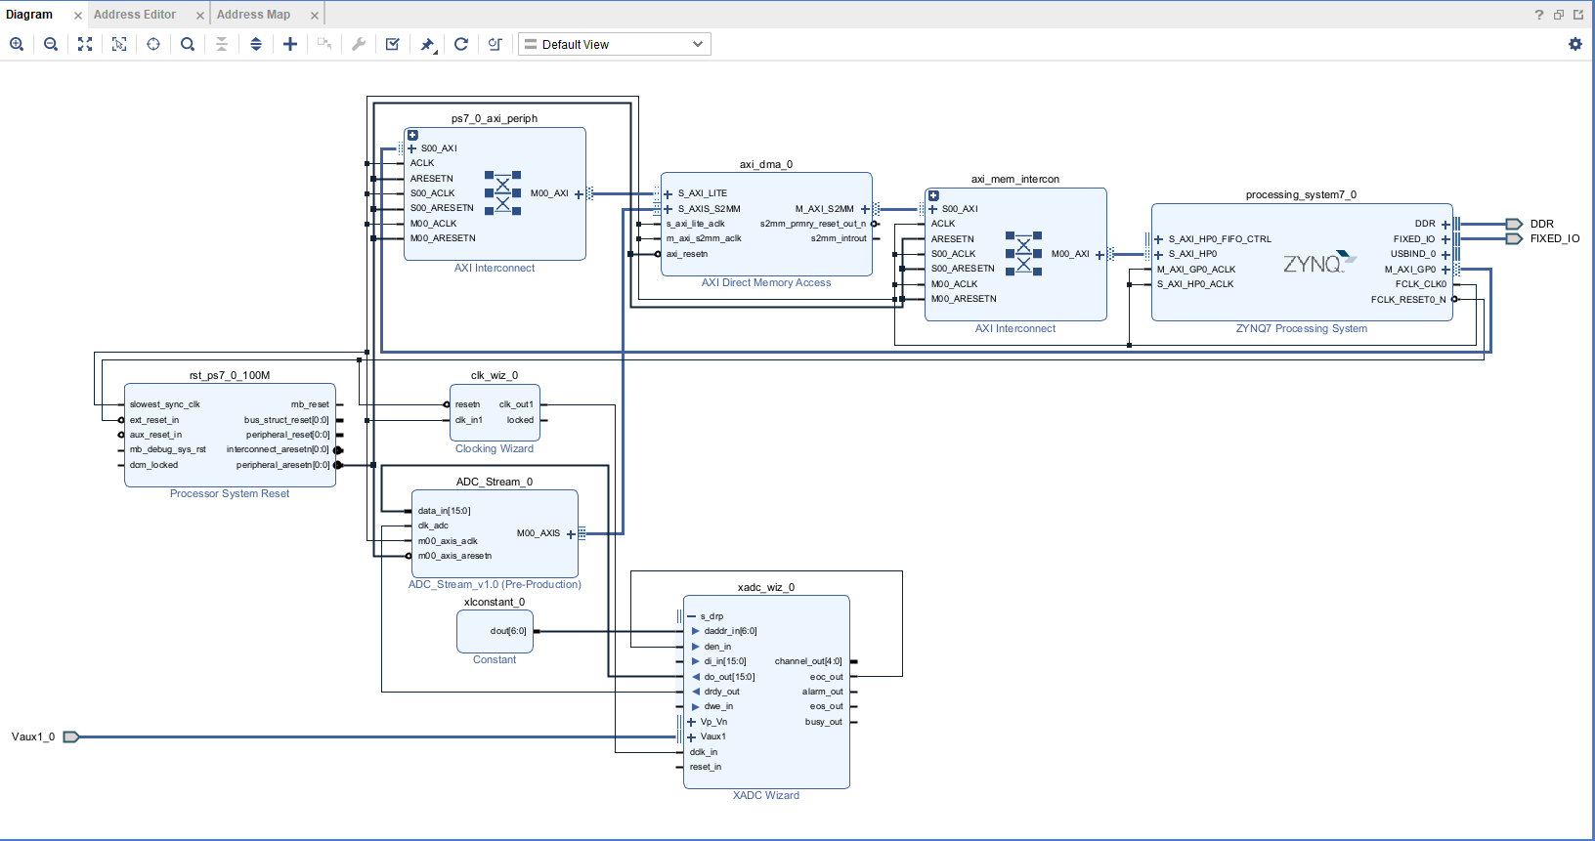

## This file is a general .xdc for the PYNQ-Z1 board Rev. C

## To use it in a project:

## - uncomment the lines corresponding to used pins

## - rename the used ports (in each line, after get_ports) according to the top level signal names in the project

## Clock signal 125 MHz

#set_property -dict { PACKAGE_PIN H16 IOSTANDARD LVCMOS33 } [get_ports { sysclk }]; #IO_L13P_T2_MRCC_35 Sch=sysclk

#create_clock -add -name sys_clk_pin -period 8.00 -waveform {0 4} [get_ports { sysclk }];

##Switches

#set_property -dict { PACKAGE_PIN M20 IOSTANDARD LVCMOS33 } [get_ports { sw[0] }]; #IO_L7N_T1_AD2N_35 Sch=sw[0]

#set_property -dict { PACKAGE_PIN M19 IOSTANDARD LVCMOS33 } [get_ports { sw[1] }]; #IO_L7P_T1_AD2P_35 Sch=sw[1]

##RGB LEDs

#set_property -dict { PACKAGE_PIN L15 IOSTANDARD LVCMOS33 } [get_ports { out_trg_0 }]; #IO_L22N_T3_AD7N_35 Sch=led4_b

#set_property -dict { PACKAGE_PIN G17 IOSTANDARD LVCMOS33 } [get_ports { led_0_5 }]; #IO_L16P_T2_35 Sch=led4_g

#set_property -dict { PACKAGE_PIN N15 IOSTANDARD LVCMOS33 } [get_ports { led_0_6 }]; #IO_L21P_T3_DQS_AD14P_35 Sch=led4_r

#set_property -dict { PACKAGE_PIN G14 IOSTANDARD LVCMOS33 } [get_ports { led_0[0] }]; #IO_0_35 Sch=led5_b

#set_property -dict { PACKAGE_PIN L14 IOSTANDARD LVCMOS33 } [get_ports { led_0[1] }]; #IO_L22P_T3_AD7P_35 Sch=led5_g

#set_property -dict { PACKAGE_PIN M15 IOSTANDARD LVCMOS33 } [get_ports { led_0[2] }]; #IO_L23N_T3_35 Sch=led5_r

##LEDs

#set_property -dict { PACKAGE_PIN R14 IOSTANDARD LVCMOS33 } [get_ports { led_0[0] }]; #IO_L6N_T0_VREF_34 Sch=led[0]

#set_property -dict { PACKAGE_PIN P14 IOSTANDARD LVCMOS33 } [get_ports { led_0[1] }]; #IO_L6P_T0_34 Sch=led[1]

#set_property -dict { PACKAGE_PIN N16 IOSTANDARD LVCMOS33 } [get_ports { led_0[2] }]; #IO_L21N_T3_DQS_AD14N_35 Sch=led[2]

#set_property -dict { PACKAGE_PIN M14 IOSTANDARD LVCMOS33 } [get_ports { led_0[3] }]; #IO_L23P_T3_35 Sch=led[3]

##Buttons

#set_property -dict { PACKAGE_PIN D19 IOSTANDARD LVCMOS33 } [get_ports { in_sig_0 }]; #IO_L4P_T0_35 Sch=btn[0]

#set_property CLOCK_DEDICATED_ROUTE FALSE [get_nets { in_sig_0_IBUF }];

#set_property -dict { PACKAGE_PIN D20 IOSTANDARD LVCMOS33 } [get_ports { fifo_en_0 }]; #IO_L4N_T0_35 Sch=btn[1]

#set_property -dict { PACKAGE_PIN L20 IOSTANDARD LVCMOS33 } [get_ports { btn[2] }]; #IO_L9N_T1_DQS_AD3N_35 Sch=btn[2]

#set_property -dict { PACKAGE_PIN L19 IOSTANDARD LVCMOS33 } [get_ports { btn[3] }]; #IO_L9P_T1_DQS_AD3P_35 Sch=btn[3]

##Pmod Header JA

#set_property -dict { PACKAGE_PIN Y18 IOSTANDARD LVCMOS33 } [get_ports { ja[0] }]; #IO_L17P_T2_34 Sch=ja_p[1]

#set_property -dict { PACKAGE_PIN Y19 IOSTANDARD LVCMOS33 } [get_ports { ja[1] }]; #IO_L17N_T2_34 Sch=ja_n[1]

#set_property -dict { PACKAGE_PIN Y16 IOSTANDARD LVCMOS33 } [get_ports { ja[2] }]; #IO_L7P_T1_34 Sch=ja_p[2]

#set_property -dict { PACKAGE_PIN Y17 IOSTANDARD LVCMOS33 } [get_ports { ja[3] }]; #IO_L7N_T1_34 Sch=ja_n[2]

#set_property -dict { PACKAGE_PIN U18 IOSTANDARD LVCMOS33 } [get_ports { ja[4] }]; #IO_L12P_T1_MRCC_34 Sch=ja_p[3]

#set_property -dict { PACKAGE_PIN U19 IOSTANDARD LVCMOS33 } [get_ports { ja[5] }]; #IO_L12N_T1_MRCC_34 Sch=ja_n[3]

#set_property -dict { PACKAGE_PIN W18 IOSTANDARD LVCMOS33 } [get_ports { ja[6] }]; #IO_L22P_T3_34 Sch=ja_p[4]

#set_property -dict { PACKAGE_PIN W19 IOSTANDARD LVCMOS33 } [get_ports { ja[7] }]; #IO_L22N_T3_34 Sch=ja_n[4]

##Pmod Header JB

#set_property -dict { PACKAGE_PIN W14 IOSTANDARD LVCMOS33 } [get_ports { jb[0] }]; #IO_L8P_T1_34 Sch=jb_p[1]

#set_property -dict { PACKAGE_PIN Y14 IOSTANDARD LVCMOS33 } [get_ports { jb[1] }]; #IO_L8N_T1_34 Sch=jb_n[1]

#set_property -dict { PACKAGE_PIN T11 IOSTANDARD LVCMOS33 } [get_ports { jb[2] }]; #IO_L1P_T0_34 Sch=jb_p[2]

#set_property -dict { PACKAGE_PIN T10 IOSTANDARD LVCMOS33 } [get_ports { jb[3] }]; #IO_L1N_T0_34 Sch=jb_n[2]

#set_property -dict { PACKAGE_PIN V16 IOSTANDARD LVCMOS33 } [get_ports { jb[4] }]; #IO_L18P_T2_34 Sch=jb_p[3]

#set_property -dict { PACKAGE_PIN W16 IOSTANDARD LVCMOS33 } [get_ports { jb[5] }]; #IO_L18N_T2_34 Sch=jb_n[3]

#set_property -dict { PACKAGE_PIN V12 IOSTANDARD LVCMOS33 } [get_ports { jb[6] }]; #IO_L4P_T0_34 Sch=jb_p[4]

#set_property -dict { PACKAGE_PIN W13 IOSTANDARD LVCMOS33 } [get_ports { jb[7] }]; #IO_L4N_T0_34 Sch=jb_n[4]

##Audio Out

#set_property -dict { PACKAGE_PIN R18 IOSTANDARD LVCMOS33 } [get_ports { aud_pwm }]; #IO_L20N_T3_34 Sch=aud_pwm

#set_property -dict { PACKAGE_PIN T17 IOSTANDARD LVCMOS33 } [get_ports { aud_sd }]; #IO_L20P_T3_34 Sch=aud_sd

##Mic input

#set_property -dict { PACKAGE_PIN F17 IOSTANDARD LVCMOS33 } [get_ports { m_clk }]; #IO_L6N_T0_VREF_35 Sch=m_clk

#set_property -dict { PACKAGE_PIN G18 IOSTANDARD LVCMOS33 } [get_ports { m_data }]; #IO_L16N_T2_35 Sch=m_data

##ChipKit Single Ended Analog Inputs

##NOTE: The ck_an_p pins can be used as single ended analog inputs with voltages from 0-3.3V (Chipkit Analog pins A0-A5).

## These signals should only be connected to the XADC core. When using these pins as digital I/O, use pins ck_io[14-19].

set_property -dict { PACKAGE_PIN D18 IOSTANDARD LVCMOS33 } [get_ports { Vaux1_0_v_n }]; #IO_L3N_T0_DQS_AD1N_35 Sch=ck_an_n[0]

set_property -dict { PACKAGE_PIN E17 IOSTANDARD LVCMOS33 } [get_ports { Vaux1_0_v_p }]; #IO_L3P_T0_DQS_AD1P_35 Sch=ck_an_p[0]

#set_property -dict { PACKAGE_PIN E19 IOSTANDARD LVCMOS33 } [get_ports { Vaux9_0_v_n }]; #IO_L5N_T0_AD9N_35 Sch=ck_an_n[1]

#set_property -dict { PACKAGE_PIN E18 IOSTANDARD LVCMOS33 } [get_ports { Vaux9_0_v_p }]; #IO_L5P_T0_AD9P_35 Sch=ck_an_p[1]

#set_property -dict { PACKAGE_PIN J14 IOSTANDARD LVCMOS33 } [get_ports { Vaux6_0_v_n }]; #IO_L20N_T3_AD6N_35 Sch=ck_an_n[2]

#set_property -dict { PACKAGE_PIN K14 IOSTANDARD LVCMOS33 } [get_ports { Vaux6_0_v_p }]; #IO_L20P_T3_AD6P_35 Sch=ck_an_p[2]

#set_property -dict { PACKAGE_PIN J16 IOSTANDARD LVCMOS33 } [get_ports { Vaux15_0_v_n }]; #IO_L24N_T3_AD15N_35 Sch=ck_an_n[3]

#set_property -dict { PACKAGE_PIN K16 IOSTANDARD LVCMOS33 } [get_ports { Vaux15_0_v_p }]; #IO_L24P_T3_AD15P_35 Sch=ck_an_p[3]

#set_property -dict { PACKAGE_PIN H20 IOSTANDARD LVCMOS33 } [get_ports { ck_an_n[4] }]; #IO_L17N_T2_AD5N_35 Sch=ck_an_n[4]

#set_property -dict { PACKAGE_PIN J20 IOSTANDARD LVCMOS33 } [get_ports { ck_an_p[4] }]; #IO_L17P_T2_AD5P_35 Sch=ck_an_p[4]

#set_property -dict { PACKAGE_PIN G20 IOSTANDARD LVCMOS33 } [get_ports { ck_an_n[5] }]; #IO_L18N_T2_AD13N_35 Sch=ck_an_n[5]

#set_property -dict { PACKAGE_PIN G19 IOSTANDARD LVCMOS33 } [get_ports { ck_an_p[5] }]; #IO_L18P_T2_AD13P_35 Sch=ck_an_p[5]

##ChipKit Digital I/O Low

#set_property -dict { PACKAGE_PIN T14 IOSTANDARD LVCMOS33 } [get_ports { ck_io[0] }]; #IO_L5P_T0_34 Sch=ck_io[0]

#set_property -dict { PACKAGE_PIN U12 IOSTANDARD LVCMOS33 } [get_ports { ck_io[1] }]; #IO_L2N_T0_34 Sch=ck_io[1]

#set_property -dict { PACKAGE_PIN U13 IOSTANDARD LVCMOS33 } [get_ports { ck_io[2] }]; #IO_L3P_T0_DQS_PUDC_B_34 Sch=ck_io[2]

#set_property -dict { PACKAGE_PIN V13 IOSTANDARD LVCMOS33 } [get_ports { ck_io[3] }]; #IO_L3N_T0_DQS_34 Sch=ck_io[3]

#set_property -dict { PACKAGE_PIN V15 IOSTANDARD LVCMOS33 } [get_ports { ck_io[4] }]; #IO_L10P_T1_34 Sch=ck_io[4]

#set_property -dict { PACKAGE_PIN T15 IOSTANDARD LVCMOS33 } [get_ports { ck_io[5] }]; #IO_L5N_T0_34 Sch=ck_io[5]

#set_property -dict { PACKAGE_PIN R16 IOSTANDARD LVCMOS33 } [get_ports { ck_io[6] }]; #IO_L19P_T3_34 Sch=ck_io[6]

#set_property -dict { PACKAGE_PIN U17 IOSTANDARD LVCMOS33 } [get_ports { ck_io[7] }]; #IO_L9N_T1_DQS_34 Sch=ck_io[7]

#set_property -dict { PACKAGE_PIN V17 IOSTANDARD LVCMOS33 } [get_ports { ck_io[8] }]; #IO_L21P_T3_DQS_34 Sch=ck_io[8]

#set_property -dict { PACKAGE_PIN V18 IOSTANDARD LVCMOS33 } [get_ports { ck_io[9] }]; #IO_L21N_T3_DQS_34 Sch=ck_io[9]

#set_property -dict { PACKAGE_PIN T16 IOSTANDARD LVCMOS33 } [get_ports { ck_io[10] }]; #IO_L9P_T1_DQS_34 Sch=ck_io[10]

#set_property -dict { PACKAGE_PIN R17 IOSTANDARD LVCMOS33 } [get_ports { ck_io[11] }]; #IO_L19N_T3_VREF_34 Sch=ck_io[11]

#set_property -dict { PACKAGE_PIN P18 IOSTANDARD LVCMOS33 } [get_ports { ck_io[12] }]; #IO_L23N_T3_34 Sch=ck_io[12]

#set_property -dict { PACKAGE_PIN N17 IOSTANDARD LVCMOS33 } [get_ports { ck_io[13] }]; #IO_L23P_T3_34 Sch=ck_io[13]

##ChipKit Digital I/O On Outer Analog Header

##NOTE: These pins should be used when using the analog header signals A0-A5 as digital I/O (Chipkit digital pins 14-19)

#set_property -dict { PACKAGE_PIN Y11 IOSTANDARD LVCMOS33 } [get_ports { ck_io[14] }]; #IO_L18N_T2_13 Sch=ck_a[0]

#set_property -dict { PACKAGE_PIN Y12 IOSTANDARD LVCMOS33 } [get_ports { ck_io[15] }]; #IO_L20P_T3_13 Sch=ck_a[1]

#set_property -dict { PACKAGE_PIN W11 IOSTANDARD LVCMOS33 } [get_ports { ck_io[16] }]; #IO_L18P_T2_13 Sch=ck_a[2]

#set_property -dict { PACKAGE_PIN V11 IOSTANDARD LVCMOS33 } [get_ports { ck_io[17] }]; #IO_L21P_T3_DQS_13 Sch=ck_a[3]

#set_property -dict { PACKAGE_PIN T5 IOSTANDARD LVCMOS33 } [get_ports { ck_io[18] }]; #IO_L19P_T3_13 Sch=ck_a[4]

#set_property -dict { PACKAGE_PIN U10 IOSTANDARD LVCMOS33 } [get_ports { ck_io[19] }]; #IO_L12N_T1_MRCC_13 Sch=ck_a[5]

##ChipKit Digital I/O On Inner Analog Header

##NOTE: These pins will need to be connected to the XADC core when used as differential analog inputs (Chipkit analog pins A6-A11)

#set_property -dict { PACKAGE_PIN B20 IOSTANDARD LVCMOS33 } [get_ports { ck_io[20] }]; #IO_L1N_T0_AD0N_35 Sch=ad_n[0]

#set_property -dict { PACKAGE_PIN C20 IOSTANDARD LVCMOS33 } [get_ports { ck_io[21] }]; #IO_L1P_T0_AD0P_35 Sch=ad_p[0]

#set_property -dict { PACKAGE_PIN F20 IOSTANDARD LVCMOS33 } [get_ports { ck_io[22] }]; #IO_L15N_T2_DQS_AD12N_35 Sch=ad_n[12]

#set_property -dict { PACKAGE_PIN F19 IOSTANDARD LVCMOS33 } [get_ports { ck_io[23] }]; #IO_L15P_T2_DQS_AD12P_35 Sch=ad_p[12]

#set_property -dict { PACKAGE_PIN A20 IOSTANDARD LVCMOS33 } [get_ports { ck_io[24] }]; #IO_L2N_T0_AD8N_35 Sch=ad_n[8]

#set_property -dict { PACKAGE_PIN B19 IOSTANDARD LVCMOS33 } [get_ports { ck_io[25] }]; #IO_L2P_T0_AD8P_35 Sch=ad_p[8]

##ChipKit Digital I/O High

#set_property -dict { PACKAGE_PIN U5 IOSTANDARD LVCMOS33 } [get_ports { ck_io[26] }]; #IO_L19N_T3_VREF_13 Sch=ck_io[26]

#set_property -dict { PACKAGE_PIN V5 IOSTANDARD LVCMOS33 } [get_ports { ck_io[27] }]; #IO_L6N_T0_VREF_13 Sch=ck_io[27]

#set_property -dict { PACKAGE_PIN V6 IOSTANDARD LVCMOS33 } [get_ports { ck_io[28] }]; #IO_L22P_T3_13 Sch=ck_io[28]

#set_property -dict { PACKAGE_PIN U7 IOSTANDARD LVCMOS33 } [get_ports { ck_io[29] }]; #IO_L11P_T1_SRCC_13 Sch=ck_io[29]

#set_property -dict { PACKAGE_PIN V7 IOSTANDARD LVCMOS33 } [get_ports { ck_io[30] }]; #IO_L11N_T1_SRCC_13 Sch=ck_io[30]

#set_property -dict { PACKAGE_PIN U8 IOSTANDARD LVCMOS33 } [get_ports { ck_io[31] }]; #IO_L17N_T2_13 Sch=ck_io[31]

#set_property -dict { PACKAGE_PIN V8 IOSTANDARD LVCMOS33 } [get_ports { ck_io[32] }]; #IO_L15P_T2_DQS_13 Sch=ck_io[32]

#set_property -dict { PACKAGE_PIN V10 IOSTANDARD LVCMOS33 } [get_ports { ck_io[33] }]; #IO_L21N_T3_DQS_13 Sch=ck_io[33]

#set_property -dict { PACKAGE_PIN W10 IOSTANDARD LVCMOS33 } [get_ports { ck_io[34] }]; #IO_L16P_T2_13 Sch=ck_io[34]

#set_property -dict { PACKAGE_PIN W6 IOSTANDARD LVCMOS33 } [get_ports { ck_io[35] }]; #IO_L22N_T3_13 Sch=ck_io[35]

#set_property -dict { PACKAGE_PIN Y6 IOSTANDARD LVCMOS33 } [get_ports { ck_io[36] }]; #IO_L13N_T2_MRCC_13 Sch=ck_io[36]

#set_property -dict { PACKAGE_PIN Y7 IOSTANDARD LVCMOS33 } [get_ports { ck_io[37] }]; #IO_L13P_T2_MRCC_13 Sch=ck_io[37]

#set_property -dict { PACKAGE_PIN W8 IOSTANDARD LVCMOS33 } [get_ports { ck_io[38] }]; #IO_L15N_T2_DQS_13 Sch=ck_io[38]

#set_property -dict { PACKAGE_PIN Y8 IOSTANDARD LVCMOS33 } [get_ports { ck_io[39] }]; #IO_L14N_T2_SRCC_13 Sch=ck_io[39]

#set_property -dict { PACKAGE_PIN W9 IOSTANDARD LVCMOS33 } [get_ports { ck_io[40] }]; #IO_L16N_T2_13 Sch=ck_io[40]

#set_property -dict { PACKAGE_PIN Y9 IOSTANDARD LVCMOS33 } [get_ports { ck_io[41] }]; #IO_L14P_T2_SRCC_13 Sch=ck_io[41]

#set_property -dict { PACKAGE_PIN Y13 IOSTANDARD LVCMOS33 } [get_ports { ck_io[42] }]; #IO_L20N_T3_13 Sch=ck_ioa

## ChipKit SPI

#set_property -dict { PACKAGE_PIN W15 IOSTANDARD LVCMOS33 } [get_ports { ck_miso }]; #IO_L10N_T1_34 Sch=ck_miso

#set_property -dict { PACKAGE_PIN T12 IOSTANDARD LVCMOS33 } [get_ports { ck_mosi }]; #IO_L2P_T0_34 Sch=ck_mosi

#set_property -dict { PACKAGE_PIN H15 IOSTANDARD LVCMOS33 } [get_ports { ck_sck }]; #IO_L19P_T3_35 Sch=ck_sck

#set_property -dict { PACKAGE_PIN F16 IOSTANDARD LVCMOS33 } [get_ports { ck_ss }]; #IO_L6P_T0_35 Sch=ck_ss

## ChipKit I2C

#set_property -dict { PACKAGE_PIN P16 IOSTANDARD LVCMOS33 } [get_ports { ck_scl }]; #IO_L24N_T3_34 Sch=ck_scl

#set_property -dict { PACKAGE_PIN P15 IOSTANDARD LVCMOS33 } [get_ports { ck_sda }]; #IO_L24P_T3_34 Sch=ck_sda

##HDMI Rx

#set_property -dict { PACKAGE_PIN H17 IOSTANDARD LVCMOS33 } [get_ports { hdmi_rx_cec }]; #IO_L13N_T2_MRCC_35 Sch=hdmi_rx_cec

#set_property -dict { PACKAGE_PIN P19 IOSTANDARD TMDS_33 } [get_ports { hdmi_rx_clk_n }]; #IO_L13N_T2_MRCC_34 Sch=hdmi_rx_clk_n

#set_property -dict { PACKAGE_PIN N18 IOSTANDARD TMDS_33 } [get_ports { hdmi_rx_clk_p }]; #IO_L13P_T2_MRCC_34 Sch=hdmi_rx_clk_p

#set_property -dict { PACKAGE_PIN W20 IOSTANDARD TMDS_33 } [get_ports { hdmi_rx_d_n[0] }]; #IO_L16N_T2_34 Sch=hdmi_rx_d_n[0]

#set_property -dict { PACKAGE_PIN V20 IOSTANDARD TMDS_33 } [get_ports { hdmi_rx_d_p[0] }]; #IO_L16P_T2_34 Sch=hdmi_rx_d_p[0]

#set_property -dict { PACKAGE_PIN U20 IOSTANDARD TMDS_33 } [get_ports { hdmi_rx_d_n[1] }]; #IO_L15N_T2_DQS_34 Sch=hdmi_rx_d_n[1]

#set_property -dict { PACKAGE_PIN T20 IOSTANDARD TMDS_33 } [get_ports { hdmi_rx_d_p[1] }]; #IO_L15P_T2_DQS_34 Sch=hdmi_rx_d_p[1]

#set_property -dict { PACKAGE_PIN P20 IOSTANDARD TMDS_33 } [get_ports { hdmi_rx_d_n[2] }]; #IO_L14N_T2_SRCC_34 Sch=hdmi_rx_d_n[2]

#set_property -dict { PACKAGE_PIN N20 IOSTANDARD TMDS_33 } [get_ports { hdmi_rx_d_p[2] }]; #IO_L14P_T2_SRCC_34 Sch=hdmi_rx_d_p[2]

#set_property -dict { PACKAGE_PIN T19 IOSTANDARD LVCMOS33 } [get_ports { hdmi_rx_hpd }]; #IO_25_34 Sch=hdmi_rx_hpd

#set_property -dict { PACKAGE_PIN U14 IOSTANDARD LVCMOS33 } [get_ports { hdmi_rx_scl }]; #IO_L11P_T1_SRCC_34 Sch=hdmi_rx_scl

#set_property -dict { PACKAGE_PIN U15 IOSTANDARD LVCMOS33 } [get_ports { hdmi_rx_sda }]; #IO_L11N_T1_SRCC_34 Sch=hdmi_rx_sda

##HDMI Tx

#set_property -dict { PACKAGE_PIN G15 IOSTANDARD LVCMOS33 } [get_ports { hdmi_tx_cec }]; #IO_L19N_T3_VREF_35 Sch=hdmi_tx_cec

#set_property -dict { PACKAGE_PIN L17 IOSTANDARD TMDS_33 } [get_ports { hdmi_tx_clk_n }]; #IO_L11N_T1_SRCC_35 Sch=hdmi_tx_clk_n

#set_property -dict { PACKAGE_PIN L16 IOSTANDARD TMDS_33 } [get_ports { hdmi_tx_clk_p }]; #IO_L11P_T1_SRCC_35 Sch=hdmi_tx_clk_p

#set_property -dict { PACKAGE_PIN K18 IOSTANDARD TMDS_33 } [get_ports { hdmi_tx_d_n[0] }]; #IO_L12N_T1_MRCC_35 Sch=hdmi_tx_d_n[0]

#set_property -dict { PACKAGE_PIN K17 IOSTANDARD TMDS_33 } [get_ports { hdmi_tx_d_p[0] }]; #IO_L12P_T1_MRCC_35 Sch=hdmi_tx_d_p[0]

#set_property -dict { PACKAGE_PIN J19 IOSTANDARD TMDS_33 } [get_ports { hdmi_tx_d_n[1] }]; #IO_L10N_T1_AD11N_35 Sch=hdmi_tx_d_n[1]

#set_property -dict { PACKAGE_PIN K19 IOSTANDARD TMDS_33 } [get_ports { hdmi_tx_d_p[1] }]; #IO_L10P_T1_AD11P_35 Sch=hdmi_tx_d_p[1]

#set_property -dict { PACKAGE_PIN H18 IOSTANDARD TMDS_33 } [get_ports { hdmi_tx_d_n[2] }]; #IO_L14N_T2_AD4N_SRCC_35 Sch=hdmi_tx_d_n[2]

#set_property -dict { PACKAGE_PIN J18 IOSTANDARD TMDS_33 } [get_ports { hdmi_tx_d_p[2] }]; #IO_L14P_T2_AD4P_SRCC_35 Sch=hdmi_tx_d_p[2]

#set_property -dict { PACKAGE_PIN R19 IOSTANDARD LVCMOS33 } [get_ports { hdmi_tx_hpdn }]; #IO_0_34 Sch=hdmi_tx_hpdn

#set_property -dict { PACKAGE_PIN M17 IOSTANDARD LVCMOS33 } [get_ports { hdmi_tx_scl }]; #IO_L8P_T1_AD10P_35 Sch=hdmi_tx_scl

#set_property -dict { PACKAGE_PIN M18 IOSTANDARD LVCMOS33 } [get_ports { hdmi_tx_sda }]; #IO_L8N_T1_AD10N_35 Sch=hdmi_tx_sda

##Crypto SDA

#set_property -dict { PACKAGE_PIN J15 IOSTANDARD LVCMOS33 } [get_ports { crypto_sda }]; #IO_25_35 Sch=crypto_sda

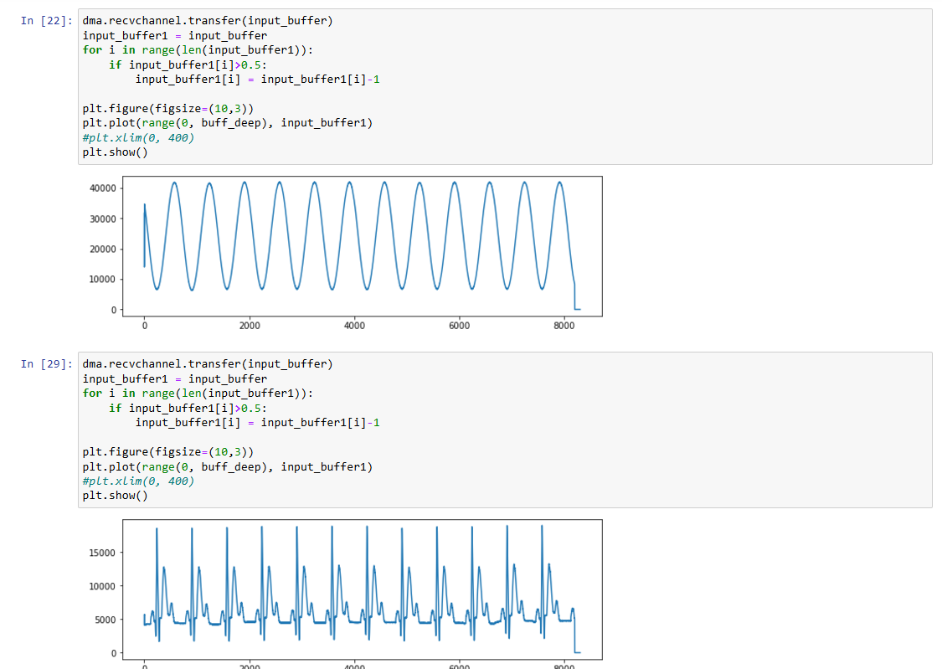

from pynq import PL

from pynq import Overlay

from pynq import allocate

import numpy as np

import matplotlib.pyplot as plt

PL.reset()

xadc_stream = Overlay('xstream.bit')

dma = xadc_stream.axi_dma_0

buff_deep = 8300

input_buffer = allocate(shape=(buff_deep,), dtype=np.uint32)

dma.recvchannel.transfer(input_buffer)

input_buffer1 = input_buffer

for i in range(len(input_buffer1)):

if input_buffer1[i]>0.5:

input_buffer1[i] = input_buffer1[i]-1

plt.figure(figsize=(10,3))

plt.plot(range(0, buff_deep), input_buffer1)

#plt.xlim(0, 400)

plt.show()